Dashboard Data Visualizations

Sergio Mateos

Southern New Hampshire University

1. Background pattern

   Description automatically generated with low confidenceOpen the ModuleSixMilestone.ipynb
2. Graphical user interface, text, application, email

   Description automatically generatedUpdate code to create an interactive data table

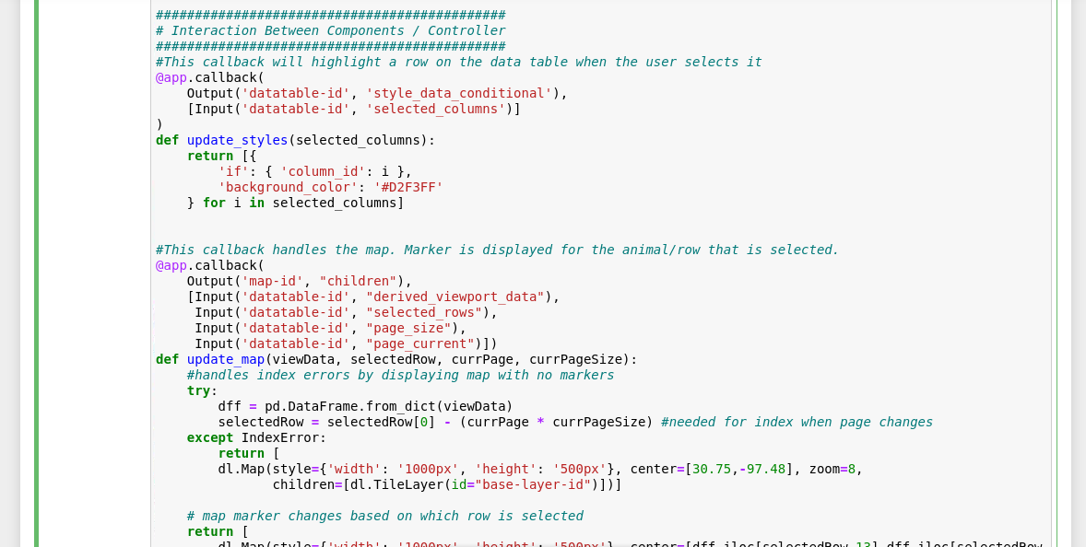

1. Add a geolocation chart that display data from the interactive data table
   1. Text

      Description automatically generatedUpdate_map
   2. Dashboard code by putting the correct statement in the layout
   3. Text

      Description automatically generatedAdd in the correct callback routine for the geolocation chart
2. Graphical user interface, text, application

   Description automatically generatedData
3. 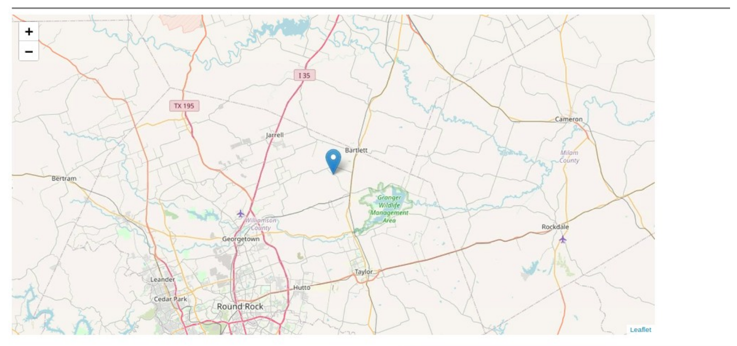Geographic location